
Mut Ict Website
Internet Programming II

May 13, 2026
Assessment 2
Mangosuthu University of Technology

Introduction
The reason behind this assessment is to improve the original MUT’s ICT department to a smart web application. We plan to use HTML, CSS, JavaScript for frontend and Node.js, Express for the backend.
Problem
The problem with MUT’s ICT website is that there is a lot of scrolling. The website is like a pdf, there is too much information to read through. The website does not cover the important things offered by the ICT department like the modules each year has. The website is outdated.
UXD and Frontend design
- Poor layout
- Too much scrolling
- There is a lot of information that is not relevant
- There is no image processing
- There are no links
- Everything is just squashed into the same webpage
- There is no feedback
- There is no chatbot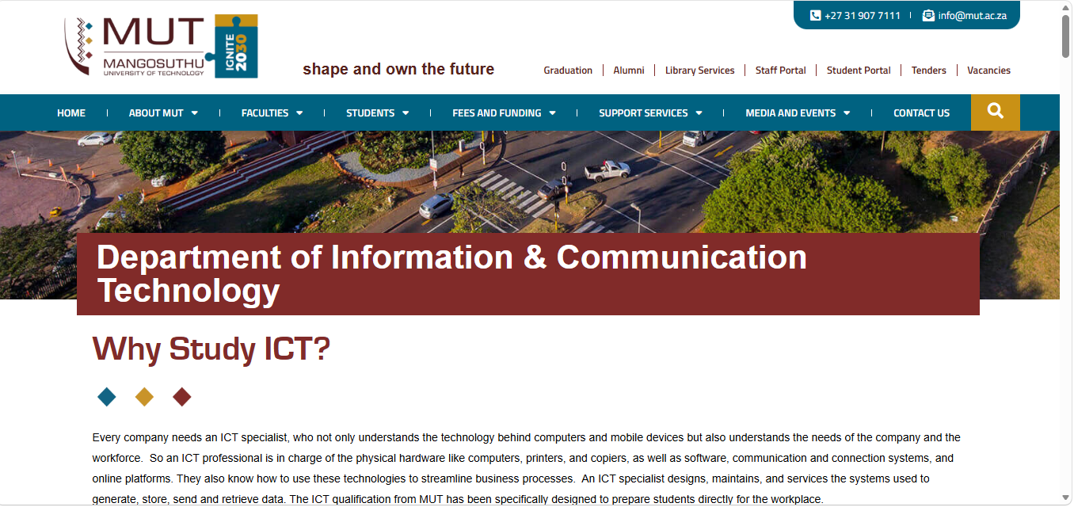
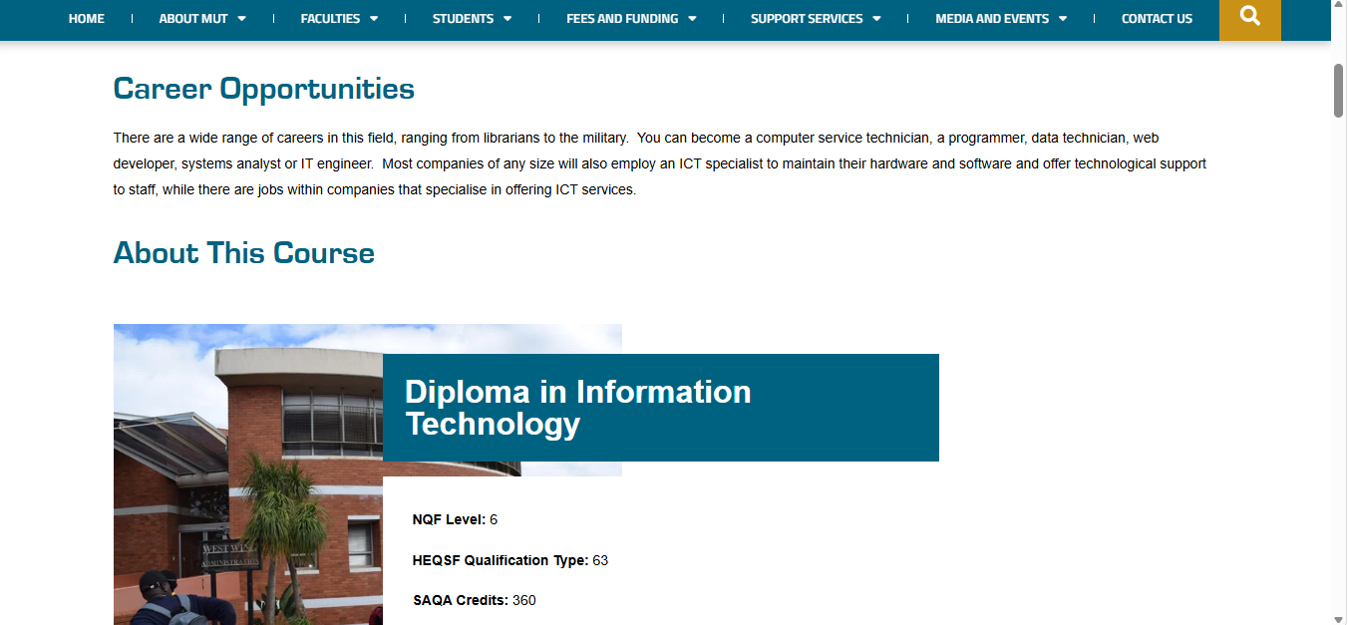
Website Proposal
- Minimize scrolling
- Important links available
- Improved layout
- User friendly site
- Smart search
- Chatbot
- Faculty announcements
- Clear homepage and menu
- Reduces white spaces

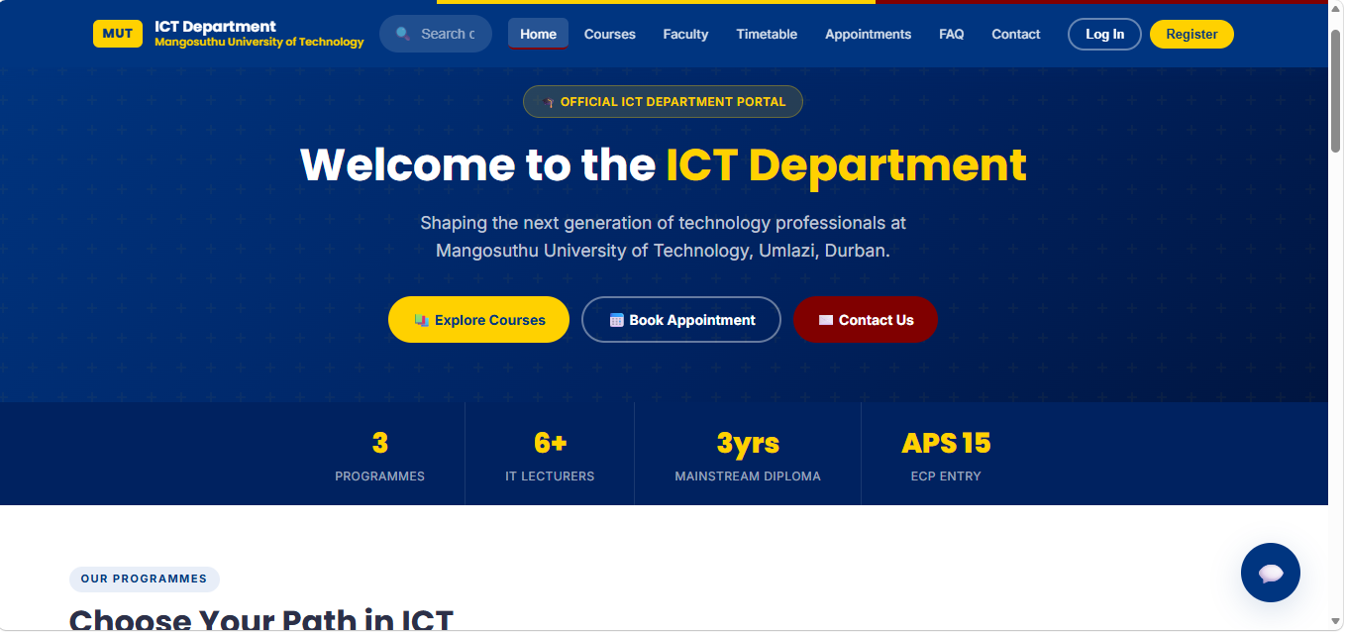
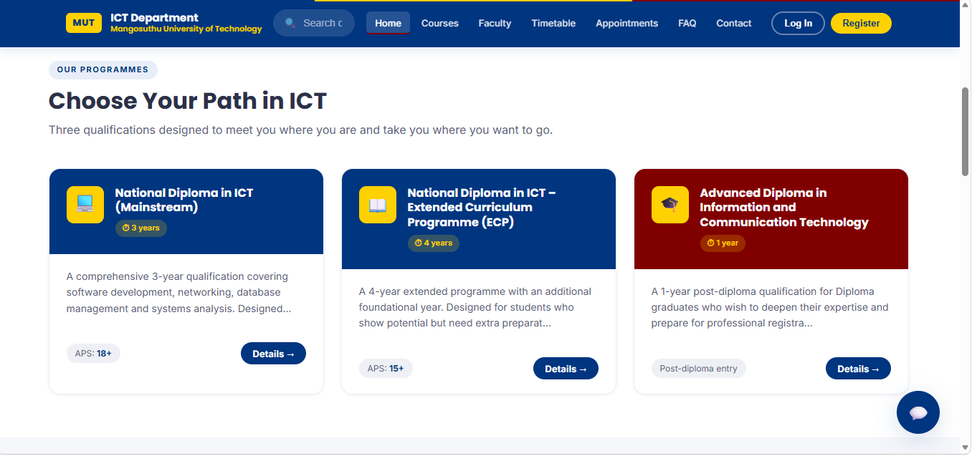

Frontend Interactivity
- Chatbot
- Appointment form
- Timetable uploads
- Profile image upload
- Creating an account
- Logging in to the website
- Buttons working
- Navigation
- Links
- Smart search
- Course pop-ups
- Responsive webpages

Backend Development
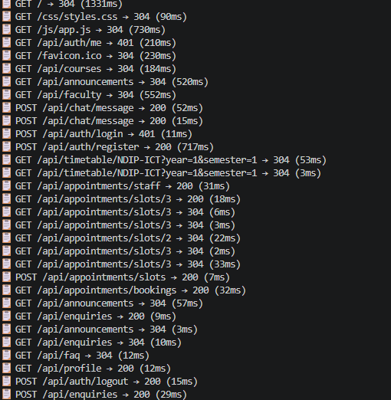
Database Design
JSON was used to store and manage departmental information. CRUD operations were implemented to allow users to create, read, update and delete appointments.
Middleware and Error Handling
We used authentication middleware to forbid a user to book an appointment if they have not logged in. Then used logging middleware for the user to log their details. Validation middleware is used to ensure that the information the user enters is the same as the one stored on the database. Error handling middleware was used to return an error message to the in case they want to book an appointment unlogged.
Smart Feature
Chatbot (Lexi)
We chose Lexi because it sounds like a friendly name and it has a universal pronunciation. We think it’s easier to remember than all the AI names like we did not put AI as a prefix or suffix. Lexi is a humanised name, we think our users will feel like they are speaking to human more than an AI.
Users can ask her any question, and she will answer based on the information given. Help students quickly access information about modules, registration and departmental services. She can also redirect the user to the department if the question is complicated by providing an email address.
Smart search
Helps the user get information faster by predicting what the user wanted to search. Makes the web search more user interactive.
Group contributions
Group members | Student Number | Contribution
B.X Cele | 22301773 | Frontend design
L Phungula | 22315843 | Backend routes
P.S Makhathini | 22325114 | Database integration
N Hlongwane | 22333548 | Testing and documentation

To sum up what has been stated above, the project successfully transformed the ICT Department website into a smart and interactive full-stack web application. The system improved user experience introduced backend functionality and demonstrated practical web development skills.

Project Installation
Step 1: extract the folder Mut-ICT website
Step 2: Open command prompt from the folder location.
step 3: Type cd mut-ict, press enter.
step 4: Type code . press enter
step 5: Open terminal
step 6: Type npm install, press enter to install database
step 7: Type npm start, press enter
step 8: copy and paste the link provided in vs code and open it in the browser.

